**Eurojust-EJN Joint Note on the practical application of the EIO**

15/07/2019

**Eurojust and the**[**European Judicial Network (EJN)**](https://www.ejn-crimjust.europa.eu/ejn/)**joined forces to publish ‘**[**The Joint Note of Eurojust and the European Judicial Network on the practical application of the European Investigation Order**](http://www.eurojust.europa.eu/doclibrary/Eurojust-framework/Casework/Joint%20note%20of%20Eurojust%20and%20the%20EJN%20on%20the%20practical%20application%20of%20the%20European%20Investigation%20Order%20(June%202019)/2019-06-Joint_Note_EJ-EJN_practical_application_EIO.pdf)**’ in June 2019 to support the work of national authorities dealing with European Investigation Orders (EIOs). The Joint Note serves as guidance on the use of the EIO for judicial practitioners: it addresses common issues and challenges in the application of the EIO Directive and includes best practice and guidelines on when and how to use the EIO in all four stages of its life cycle. The Joint Note further exemplifies the useful support offered by Eurojust and the EJN in the application of the EIO Directive.**

[[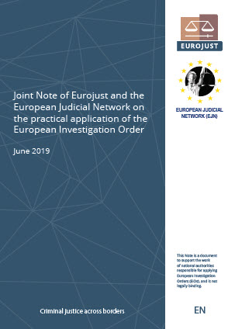](http://www.eurojust.europa.eu/doclibrary/Eurojust-framework/Casework/Joint%20note%20of%20Eurojust%20and%20the%20EJN%20on%20the%20practical%20application%20of%20the%20European%20Investigation%20Order%20(June%202019)/2019-06-Joint_Note_EJ-EJN_practical_application_EIO.pdf)](http://www.eurojust.europa.eu/doclibrary/Eurojust-framework/Casework/Joint%20note%20of%20Eurojust%20and%20the%20EJN%20on%20the%20practical%20application%20of%20the%20European%20Investigation%20Order%20(June%202019)/2019-06-Joint_Note_EJ-EJN_practical_application_EIO.pdf)The Joint Note explains the scope of the EIO Directive and advises on how to complete the EIO form, and how to best issue, transmit, recognise and execute an EIO. The Joint Note illustrates the unique bridge-making role of Eurojust and the EJN between divergent national legal systems, especially in the context of the consultation procedures. The Joint Note is an example of successful cooperation between Eurojust and the EJN in supporting judicial practitioners in the EIO application. It reflects the privileged relations of the two entities, which are based on trust and complementarity, as provided for in their legal bases.

The Joint Note will be updated on a regular basis. It is a compilation of information on the EIO and its practical application, gathered by Eurojust and the EJN from meetings, documents and casework since the entry into force of the [EIO Directive](https://eur-lex.europa.eu/legal-content/EN/TXT/PDF/?uri=CELEX:32014L0041&from=EN) in May 2017. It was published as a [Council document](https://data.consilium.europa.eu/doc/document/ST-11168-2019-INIT/en/pdf) and will be translated into all EU official languages.